Frank Allis House
4123 Monona Drive, Monona Wisconsin
Integrity Issues

The National Register criteria recognize seven discrete aspects of integrity according to the National Register. These are location, design, setting, materials, workmanship, feeling, and association. We will discuss each in turn:

Feeling/Association - The property retains its historic feeling of the rural estate of a wealthy landowner, who, in this case, aspired to be a gentleman farmer. Allis was a scion of the wealthy Allis family of Allis-Chalmers industrial fame and fortune. His 1916 farm was designed to promulgate the revolutionary tools of "progressive farming.” A primary thrust of the new farming was promoting the "iron horse," the new gas-powered tractor.

The house and its surrounding acreage represent an excellent example of the rural outpost of a wealthy gentleman farmer during the Progressive Era at the turn of the 20th Century. As such, it is likely to be a rare surviving example locally and regionally. It may be eligible under Criterion C as a property type.

Location - The Frank Allis House sits on its original site as built in 1893-4. The building retains its historical orientation to the lake, its wooded surroundings, and the road that circles Lake Monona to and from the larger neighboring City of Madison. The general surroundings of lush tree growth, distinctive tranquility, and seclusion are all very much intact.

The 1500 feet of shoreline, although modified to prevent erosion and provide easy lake access, remains undeveloped with unbroken views of Lake Monona and the Madison skyline. (These qualities inspired the City to purchase the property for park purposes.)

Design - Although there have been three significant changes to the house's exterior (which we discuss in detail later in this report), the house is still easily recognizable as a fine example of the Georgian Revival style. The primary elements of the Georgian Revival found in the Frank Allis House that are still intact and visible include:
⦁Its Gambrel roof (more often associated with the Dutch Colonial Revival, popular in the early 20th Century).
⦁The elaborate wooden tracery found in both the three-quarter length flanking entry windows and the detailed Palladian window in the central gable.
⦁The house's main block retains its original compound belt courses, raking cornices, and returned eaves.
⦁The interior retains many of its original architectural details, especially those of the first-floor main rooms and the seven bedrooms with faux-tile fireplaces.

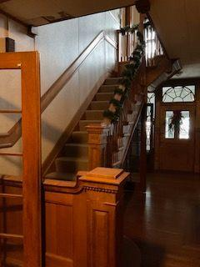
The open carved-oak stairway with a half-turn-with-landings configuration dominates the central hall. In addition, the stairway features square, paneled newel posts ornamented with dentils and a balustrade with slender balusters and scroll-sawn stringers. The walls of the central hall exhibit wooden wainscot enriched with patera, compound moldings, and dentils. (In architecture, patera (pl. paterae) is an ornamental circular or oval bas-relief disc. The patera is usually used to decorate friezes and walls, and to interrupt moldings. Patera is also often used in furniture-making.)

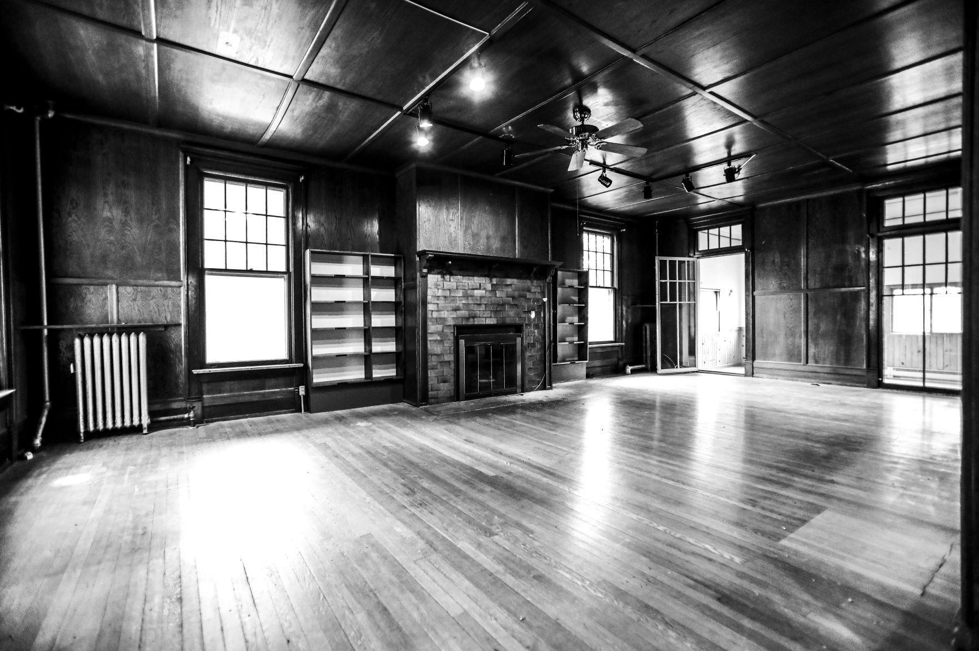

The library exhibits wooden wainscotting, which rises nearly to the plastered ceiling.

Similar wooden paneling covers the walls and ceiling in the parlor, where the largest fireplace is found.

Interior view of the library of the Frank Allis House. (Ruthie Hauge, Cap Times, July 31, 2021)

Setting - The Frank Allis estate once encompassed well over 600 acres. The main house and its immediately surrounding 10 acres were always separated by the main road (Monona Drive), which serves much as it did when it was first built. The house is 400 feet from the road, shielding it from the traffic running past.

It should also be noted that many retaining walls were built for the Frank Allis estate along the Lake Monona shoreline to prevent erosion and accommodate easy access to the lakeshore. This stonework is still intact and serves the same functions it did when first built.

Materials - Although obscured by the application of transite siding, the original clapboard can still be seen intact underneath.

The building, as it currently stands, still exhibits the original double-hung 12/1 wooden windows. The decorative tracery of the flanking three-quarter length entry windows and the highly-decorative Palladian window in the center gable is still in place and have retained their integrity.

The open wooden carved oak stairway in the central hallway is still in place and well-maintained.

The seven fireplaces retain their original decorative plasterwork that simulates glazed tile.

Workmanship - The house was well-built. The majority of the decorative qualities that the house originally exhibited remain intact. Much of the structural system, overbuilt per current-day standards, remains in place and is more than serviceable. Although there have been some inappropriate remodelings, much of that was limited to the secondary, non-public areas of the house, such as the kitchen and bathrooms.

Primary Integrity Issues

Elizabeth Miller's 2007 Determination of Eligibility compared the Frank Allis house with other Georgian Revival homes in the region. It determined that the Allis House is one of the better examples of the style in Dane County. If the property’s integrity was restored, then it would follow that the property would be eligible for listing in the National Register of Historic Places.

Three particular integrity issues could be addressed. If sympathetically undertaken, they would restore the property's historical integrity such that it would be eligible for listing in the National Register. We request an opportunity for consultation from the Historic Preservation Office on the following three discrete work items. The three primary work items, in order of significance, are as follows:

1) Remove the front entry pavilion

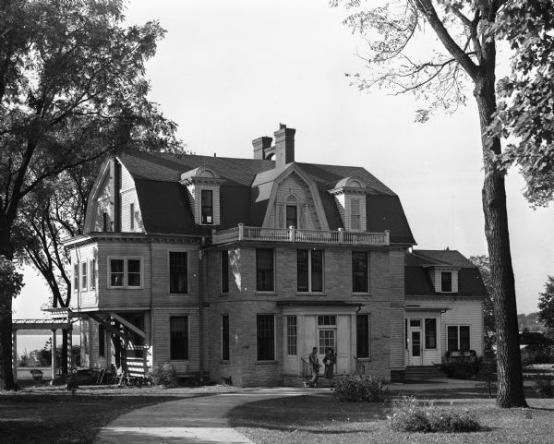
Exterior view of Norbertine Novitiate, 4123 Monona Drive. Originally the Frank Allis home was built in 1893-94.

WHS Image: 48708
Creation date: October 8, 1947
Note: Wooden clapboard siding is still exposed.

Frank Custer photo (c. 1965)

The front entry pavilion was in place by the 1940s and probably dates back to when the Norbertines owned the house. This unsympathetic addition sits squarely in the middle of the main facade. Its stone cladding is entirely out of character with its historic Georgian Revival styling and is the primary integrity issue for this property.

Removing this c. 1940 entry pavilion would go a long way in "turning back the clock" to the building's earlier historic elegance. It should be noted that the entry pavilion incorporates a few older 12/1 double-hung windows that might have been borrowed from elsewhere in the house. These would be carefully salvaged for potential reuse in any future rehabilitation.

It should also be noted that the front entry pavilion covers the original three-quarter length flanking entry windows and the entry door. Also intact are the second-floor windows, which are also obscured by the non-contributing, inappropriate modern entry addition.

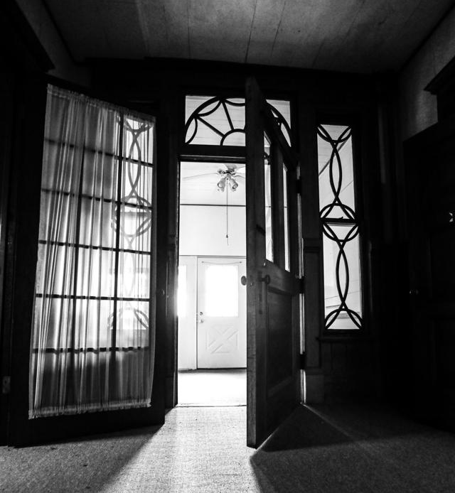

Interior view looking out through the original front entry and flanking entry windows. (Ruthie Hauge, Cap Times, July 31, 2021
2) Remove the exterior transite siding
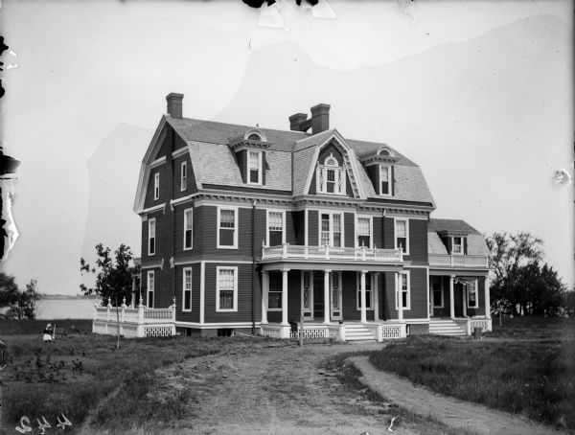

Historic photos reveal that the Frank Allis House initially exhibited clapboard siding with two different gauges, with the upper story clapboard siding being narrower than the lower.

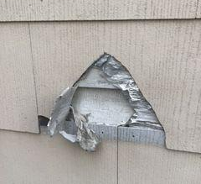

A current-day examination of the exterior reveals in spots that the original clapboard has survived underneath the newer asbestos transite siding. Selectively removing the transite siding would make a significant improvement in restoring the building's historic integrity.

Photo by Rick Bernstein December 2022
3) Remove the second-story sleeping porch.

The sleeping open-air porch dates back to Post-World War I when their popularity was common during the outbreak of the Spanish Flu and tuberculosis. At that time, the house was owned by a local doctor who was probably familiar with the proclaimed health advantages of open-air porches.

The design of the sleeping porch used sympathetic materials and replicated the clapboard exterior, as well as the classical cornice work found elsewhere in the house. It does, nonetheless, detract from the building's otherwise strict symmetry. Therefore its removal would also strongly contribute to the property's integrity and National Register eligibility.

NOTE: The July 23, 2007 letter from Daina Penkiunas, National Register coordinator, mentions other integrity issues. But since those would involve the affirmative replacement or reconstruction of lost items, they would involve more extensive efforts than the removals we have discussed above. As such, these other lesser, secondary integrity issues should be considered separately should those listed above not prove sufficient.

WHS Image ID: | 48708
Creation Date: | October 10, 1947
Creator Name: | Arthur M. Vinje

